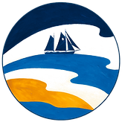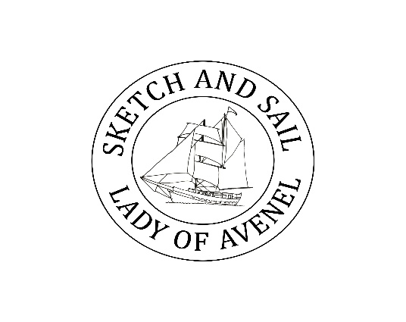
Lady of Avenel and The Changing Tides Initiative
Emerging Artists Bursaries 2026
The tall ship the Lady of Avenel and the Changing Tides Initiative have combined to fund two fully funded bursaries for emerging artists.
The Lady of Avenel is a 102ft Brigantine square rigged ship which is based on the west coast of Scotland and provides a spectacular platform to engage with the environment to combine sailing, adventure and arts based sailing voyages.
The Changing Tides Initiative is a new Scottish coastal charity whose core objects support maritime heritage and foster connections to the environment to develop environmental awareness through the arts. We aim to connect and engage with artists to interpret maritime history and the environment through various artistic mediums related to a range of environmental themes.
We are inviting applications from Shetland based artists full funded bursaries for a voyage on the Lady of Avenel on their Shetland Sketch and Sail passage from 31st May to 6th June, 2026. The scheme offers two fully funded place(s) for artist(s) to join the voyage.
The bursaries are offered to support emerging visual artists who might not usually have access to an experience like this and is specifically focused on any medium for whom drawing is a part of their practice. The passage is a week of sailing and sketching, so this is an opportunity to combine hands-on sailing and sketching. Participants on the voyage take part in workshops and tuition, help sailing if they wish, and build confidence through collaboration, adventure and shared discovery.
How to apply
Please note the closing date for applications is: Friday 8th May 2026.
Please address the following criteria in maximum 500 words:
1. How your participation on this voyage will benefit you, your work and the broader environment?
2. What contribution could you make during and beyond the voyage to communicate the key objectives of the Changing Tides Initiative e.g. blog, exhibition, community workshops.
Please include an appendix with a short biography (100 words) and 6 images of your work. This is a week of sketching, so please send us examples of your sketching as jpg images.
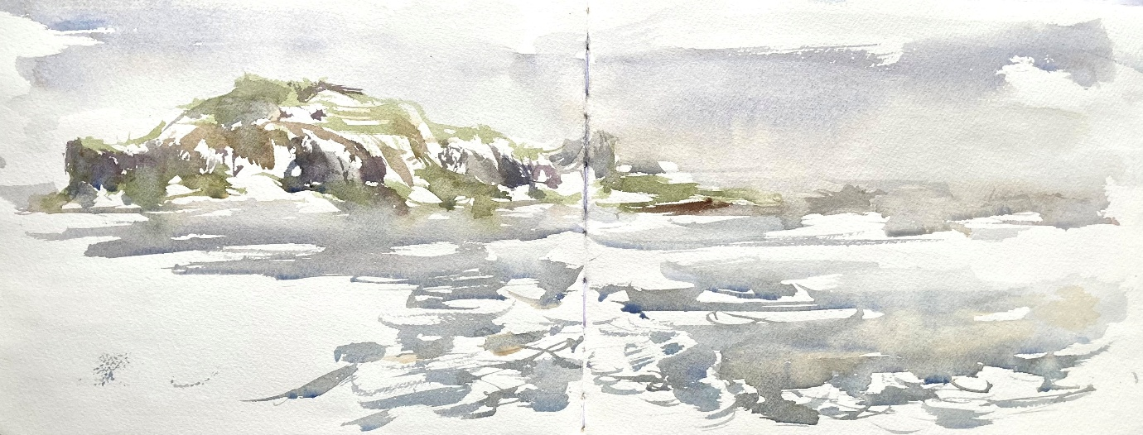
Sketch book from Alice Angus: see https://www.ladyofavenel.com/sketchandsail
This opportunity is open to people over 18.
The Lady of Avenel is a Tall ship so please declare access requirements or any additional needs.
Applications will be evaluated by The Lady of Avenel and The Changing Tides Initiative in collaboration with an artist panel.
Submission of applications to the following email: office@ladyofavenel.com
Please add the header; Artist Bursary application
For questions or further information see:
About: Lady of Avenel - https://www.ladyofavenel.com/
About: The Changing Tides Initiative https://www.changingtidesinitiative.org.uk/
About: Sketch and Sail - https://www.ladyofavenel.com/sketchandsail

